MN1000FUSE-Xx-CSA-10PK
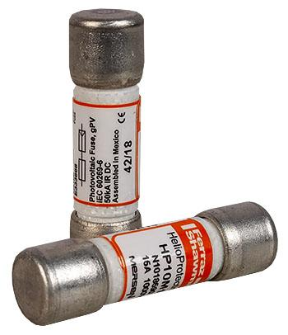
Model | Price
MN1000FUSE-Xx-CSA-10PK | $59.50
Model Options
Model | Price | Description
MN1000FUSE-15-CSA-10PK | $59.50 | Mersen’s HP10M Photovoltaic (PV) Fuse Series Was Engineered And Designed Specifically For The Protection Of Photovoltaic Systems.
Model | Price | Description
MN1000FUSE-20-CSA-10PK | $59.50 | Mersen’s HP10M Photovoltaic (PV) Fuse Series Was Engineered And Designed Specifically For The Protection Of Photovoltaic Systems. I
Model | Price | Description
MN1000FUSE-30-CSA-10PK | $59.50 | Mersen’s HP10M Photovoltaic (PV) Fuse Series Was Engineered And Designed Specifically For The Protection Of Photovoltaic Systems. I
DOCUMENTS
WEBINAR/VIDEOS
PHOTO DOWNLOAD
DESCRIPTION:
Mersen's HP10M Photovoltaic (PV) Fuse Series Was Engineered And Designed Specifically For The Protection Of Photovoltaic Systems.
Mersen's HP10M Photovoltaic (PV) Fuse Series Was Engineered And Designed Specifically For The Protection Of Photovoltaic Systems. Its Enhanced Fuse Construction Makes It Ideal For Continuous Temperature And Current Cycling Withstand Adding To System Longevity. The 1000VDC Rated HP10M, Designed For Low Minimum Breaking Capacity Capabilities Of 1.35 Times The Fuse Rated Current Value, Allows For Safe Circuit Interruption Under Typical Low Fault Current Conditions Produced By PV Arrays. Protect Your Off-Grid Or Grid Tied PV System From Unexpected Ground Faults And Line Faults Using Mersen's Helio Protection Fuse Line.

Features/Benefits:
- Low Fault Current Interrupting Capability
- Durable Construction For Enhanced System Longevity
- Temperature Cycle Withstand Capability
- Guaranteed Operation At Temperature Extremes
- Industries First UL Listed Solution
- Globally Accepted
- Listed For US And Canada

