MNE300ROSIE-240P
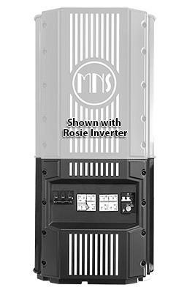
Model | Price | MAPP Price | Size | Shipping | Weight
MNE300ROSIE-240P | $890.00 | $667.50 | 13-13/16"L X 8-1/4"D X 13-15/16"W | 20-1/8"L X 11-1/2"D X 17-3/4"W - 22 Lbs | 17.5 Lbs Lbs
DOCUMENTS
WEBINAR/VIDEOS
PHOTO DOWNLOAD
DESCRIPTION:
The Rosie E-Panel Is An AC And DC Enclosure Offering Over-Current Protection (OCP) And Disconnects For AC IN, AC OUT, And To The Battery Bank.
The Rosie E-Panel Is An AC And DC Enclosure Offering Over-Current Protection (OCP) And Disconnects For AC IN, AC OUT, And To The Battery Bank. The E-Panel Is Designed Specifically For The MidNite Solar MNROSIE7048 Inverter/Charger But May Be Used With Any 120/240VAC Inverter At 60A AC IN And OUT And 65VDC/100A Out.
Standard Features Include:
- Terminal Block To Attach Optional MidNite Solar Surge Protection Devices
- Styled To Match The MNROSIE7048 Inverter/Charger
- 80VDC, 300A, Battery Positive Circuit Breaker
- 60A AC IN And AC OUT Circuit Breakers
- 60A AC Bypass Circuit
- Breaker Assembly
- Optional Backplate For Mounting
- Ground Busbar
- Listed To UL1741
ACCESSORIES
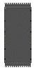
MNROSIE BACKPLATE - $150.00

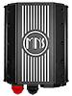
MNROSIE7048RE - $4,350.00

