MNKID-ASSY-KIT
Black
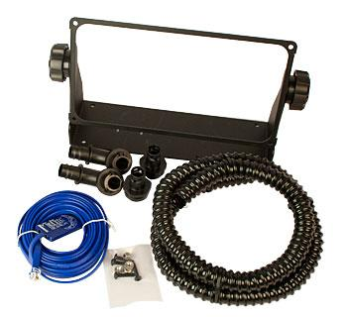
Model | Price | Shipping | Weight
MNKID-ASSY-KIT | $150.00 | 11.5"L X 11.5"W X 5"D | 3 Lbs
Model Options
Model | Price | Description
MNKID-ASSY-KIT-B | $150.00 | Black
DESCRIPTION:
MNKID Accessory Mounting Kit. Comes In Black (MNKID-ASSY-KIT-B).
MNKID-ASSY-KIT Comes With Mounting Bracket, Knobs, Screws, 4ft Flex Conduit, Battery Temperature Sensor, And Four 1/2 Connectors.

* Warranty - 5 Yrs.
* Made In The USA
California Residents: Warning

