MNKID-WMBB
Black
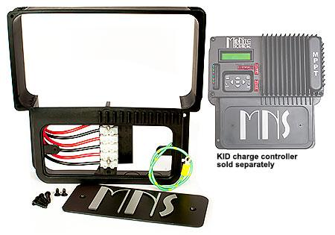
Model | Price | Size | Shipping | Weight
MNKID-WMBB | $66.00 | 9.75"L X 9"W X 1.75"D | 11.5"L X 11.5"W X 5"D | 1 Lbs
Model Options
Model | Price | Size | Shipping | Weight | Description
MNKID-WMBB-B | $66.00 | 9.75"L X 9"W X 1.75"D | 11.5"L X 11.5"W X 5"D | 1 Lbs. | Black
DESCRIPTION:
New Improved, Larger Wall Mounting Bracket For MNKID And MNKID-M. Available In Black (MNKID-WMBB-B).

It Also Includes A Front Accessible Terminal Strip For Easy Access Wiring Of The Kid.
* Warranty - 5 Yrs.
* Made In The USA
California Residents: Warning

