MNPV12-250
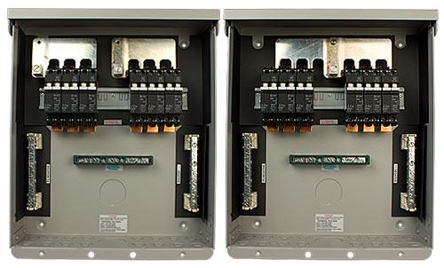
Model | Price | Size | Shipping | Weight
MNPV12-250 | $342.00 | 14.5"L X 12W" X 3.5"D | 16"L X 14"W X 5"D | 8 Lbs
DOCUMENTS
WEBINAR/VIDEOS
PHOTO DOWNLOAD
DESCRIPTION:
Enclosure Only
(For 200 And 250VDC Charge Controllers) Gray Aluminum Type 3R Rainproof Enclosure With Insulating Dead Front, Will Accept 6 300VDC Breakers.
Includes Two 15 Position PV Negative Bus Bars, 15 Position Ground Bus Bar, And 168 Amp Plus Bus Bar For Breakers. Plus Bus Bars Can Be Combined Or Separated To Support 2 High Voltage Charge Controllers. Breakers/Fuse Holders Sold Separately.
- Type 3R Environmental Rating
- Warranty - 5 Yrs.
- Listed By ETL For US & Canada
- Made In The USA
California Residents: Warning

