MNPV12
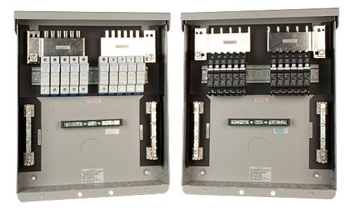
Model | Price | Size | Shipping | Weight
MNPV12 | $330.00 | 14.5"L X 12W" X 3.5"D | 16"L X 14"W X 5"D | 8 Lbs
DOCUMENTS
WEBINAR/VIDEOS
PHOTO DOWNLOAD
DESCRIPTION:
Enclosure Only
(For 150 VDC Charge Controllers And 600 VDC Grid Tie Inverters) Gray Aluminum Type 3R Rainproof Enclosure With Insulating Dead Front, Will Accept 12 150VDC Breakers Or 10 Touch-Safe Fuse Holders. Can Support Two Inverters Of Up To 5 Strings Each, Or A Transformerless Inverter Of Up To 5 Strings.
Photo Shows MNPV12 With Either Breakers Or Fuses Which Can Be Separated Or Combined.

This Combiner Can Be Configured In 3 Ways:
A Single 10 String Combiner For A Transformer Based (Grounded) Inverter Using 10 Positive Fuses
2 Separate 5 String Combiners For 2 Transformer Based (Grounded) Inverters Using 5 Positive And 5 Positive Fuses
A Single 5 String Transformer Less (Ungrounded) Combiner 5 Positive And 5 Negative Fuses

Includes 2 Isolated 15 Position PV Negative Bus Bars, 15 Position Ground Bus Bar, And 200 Amp Plus Bus Bar For Breakers And Fuses. Plus Busbars Can Be Combined Or Separated To Support 2 Inverters Or Charge Controllers.
Breakers/Fuse Holders Sold Separately.
- Type 3R Environmental Rating
- Warranty - 5 Yrs.
- Listed By ETL For US & Canada
- Made In The USA
California Residents: Warning

