MNPV2-1000
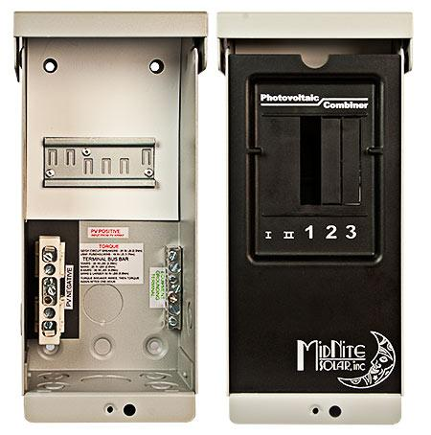
Model | Price | Size | Shipping | Weight
MNPV2-1000 | $175.00 | 10.5"L X 4.5"W X 3.5"D | 11"L X 5"W X 4"D | 2 Lbs
DOCUMENTS
WEBINAR/VIDEOS
PHOTO DOWNLOAD
DESCRIPTION:
Enclosure Only
(For 1000 VDC Grid Tie Inverters)
Gray Aluminum Type 3R Rainproof Enclosure With Deadfront, Will Accept Two 1000 VDC Fuse Holders.
Photo Shows MNPV2-1000, It Uses 1000 Volt Fuse Holders (MNTS) And Fuses (MN1000FUSE).
Includes A 2 Position Positive Bus Bar, 6 Position PV Negative Bus Bar And A 6 Position Ground Bus Bar.
Fuse Holders And Fuses Sold Separately.
- Type 3R Environmental Rating
- Warranty - 5 Yrs.
- Listed By ETL For US & Canada
- Made In The USA
California Residents: Warning

