MNPV2-MC4
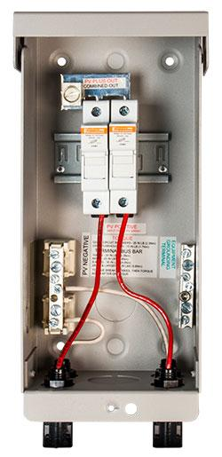
Model | Price | Size | Shipping | Weight
MNPV2-MC4 | $345.00 | 10.5"L X 4.5"W X 3.5"D | 11"L X 5"W X 4"D | 3 Lbs
DOCUMENTS
WEBINAR/VIDEOS
PHOTO DOWNLOAD
DESCRIPTION:
This 3R Pre-Wired MNPV2 Combiner Is Rated For Outdoor Use. Designed For Combining High Voltage Strings Using Standard 10mm X 38mm Fuses Up To 60 Amps Total.
The Pre-Wired MNPV2 Combiner Is Rated For Outdoor Use. Designed For Combining High Voltage Strings Using 10mm X 38mm Fuses Up To 60 Total. The Use Of Touch Safe Din Rail Mount Fuse Holders And Fuses Allow Operation Up To 600 Volts. The MNPV2 Is Rated For Up To 60 Amps.

- Type 1 Environmental Rating
- Fast, Convenient Hook Up With Industry Standard Connectors
- All Aluminum Powder Coated Housing That Won't Rust
- Flip Up Cover That Can Stay In The Open Position During Installation
- PV Negative Bus Bar With #6 And 1/0 Connections
- Chassis Ground Bus Bar With #6 And 1/0 Connections
- Standard DIN Rail With (X) 30 Amp Touch Safe Fuseholders. 15 Amp Fuses Included.
- Tin Plated Copper Bus Bar That Connect PV Plus Outputs
- Dead Front Cover Snaps Into Place After Wiring Is Complete For Safety
- Connectors For PV In And PV Out On Bottom, Additional Knockouts On Bottom And Sides
- Top Surface Is Available To Bring Conduit In From Directly Above The Enclosure

Pre-Wired Ad
- Warranty - 5 Yrs.
- Listed By ETL For US & Canada
- Made In The USA
California Residents: Warning
ACCESSORIES
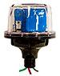
MNSPD-600 - $135.00
The MidNite Solar 600V Surge Protector Device (MNSPD) Is A Type 1 Device Per UL1449 Rev3 And Has An Outdoor Rating Of 4X For Outdoor Use. Protection For Grid-Tie PV Combiners And Inverter Input Circuits.

