MNPV3
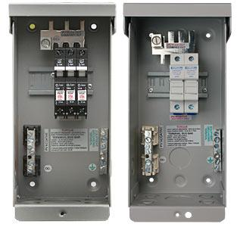
Model | Price | Size | Shipping | Weight
MNPV3 | $154.00 | 10.5"L X 4.5"W X 3.5"D | 11"L X 5"W X 4"D | 2 Lbs
DOCUMENTS
WEBINAR/VIDEOS
PHOTO DOWNLOAD
DESCRIPTION:
Enclosure Only
(For 150 VDC Charge Controllers And 600 VDC Grid Tie Inverters)
Gray Aluminum Type 3R Rainproof Enclosure With Deadfront, Will Accept Three 150VDC (MNEPV) Breakers Or Two Touch-Safe Fuse Holders.
Photo Shows MNPV3 With Either Breakers Or Fuses.
Includes A 60 Amp Plus Bus Bar, 6 Position PV Negative Bus Bar And A 6 Position Ground Bus Bar.
Breakers/Fuse Holders Sold Separately.
- Type 3R Environmental Rating
- Warranty - 5 Yrs.
- Listed By ETL For US & Canada
- Made In The USA
California Residents: Warning
ACCESSORIES

