MNPV4-1000
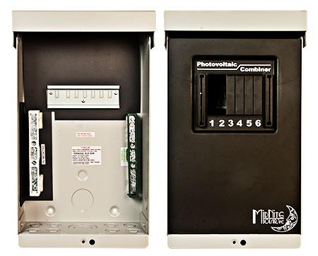
Model | Price | Size | Shipping | Weight
MNPV4-1000 | $225.00 | 13.5"L X 8"W X 3.5"D | 14"L X 9"W X 4"D | 4 Lbs
DOCUMENTS
WEBINAR/VIDEOS
PHOTO DOWNLOAD
DESCRIPTION:
Enclosure Only
(For 1000 VDC Grid Tie Inverters) Gray Aluminum Type 3R Rainproof Enclosure With Insulating Dead Front, Will Accept 4 1000VDC Fuse Holders.
Photo Shows MNPV4-1000, It Uses 1000 Volt Fuse Holders (MNTS) And Fuses (MN1000FUSE).
Includes 15 Position PV Negative Bus Bar, 14 Position Ground Bus Bar, Xx Amp Positive Bus Bar.
Fuse Holders And Fuses Sold Separately.
- Type 3R Environmental Rating
- Warranty - 5 Yrs.
- Listed By ETL For US & Canada
- Made In The USA
California Residents: Warning

