MNPV4-MC4-LV
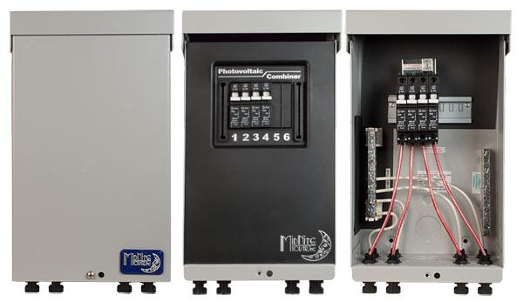
Model | Price | Size | Shipping | Weight
MNPV4-MC4-LV | $465.00 | 10.5"L X 4.5"W X 3.5"D | 11"L X 5"W X 4"D | 6 Lbs
DOCUMENTS
WEBINAR/VIDEOS
PHOTO DOWNLOAD
DESCRIPTION:
This 3R Pre-Wired MNPV4-MC4-LV Combiner Is Rated For Outdoor Use.
The Pre-Wired MNPV4 Combiner With MC4 Type Connectors, And 15A Breakers. It Is Rated For Outdoor Use. The MNPV4-MC4-LV Is Rated For Up To 120A And 150V.
- Type 1 Environmental Rating
- Fast, Convenient Hook Up With Industry Standard Connectors
- All Aluminum Powder Coated Housing That Won't Rust
- Flip Up Cover That Can Stay In The Open Position During Installation
- PV Negative Bus Bar With #6 And 1/0 Connections
- Chassis Ground Bus Bar With #6 And 1/0 Connections
- Included Dead Front Cover (MNPV6DF) Snaps Into Place After Wiring Is Complete For Safety
- Additional Knockouts On Bottom And Sides
- Warranty - 5 Yrs.
- Listed By ETL For US & Canada
- Made In The USA
California Residents: Warning
ACCESSORIES
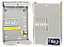
MNBIGBABY - $71.00
General Use Enclosure - Holds Up To 4 13mm Wide Din Rail Breakers From 1-63 Amps.

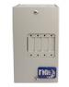
MNEDCQUAD - $92.00
General Use Aluminum Enclosure For 4 Panel Mount Type Breakers From 5 - 100 Amp.

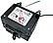
MNDC-GFP80 - $88.00
80 Amp 150VDC Panel Mount DC Ground Fault Protector (NRTL Listed Breaker Assy) 1/2 Amp Trip Mechanism Connects Between Battery Negative And Earth Ground NEC2008 Requires DC-GFPâ€™S On All Solar Installations.

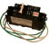
MNDC-GFP63 - $88.00
63 Amp 150VDC Din Rail Mount DC Ground Fault Protector (NRTL Listed Breaker Assy).
NEC2008 Requires DC-GFPâ€™S On All Solar Installations.

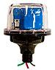
MNSPD-300-DC - $135.00
The MidNite Solar 300V Surge Protector Device (MNSPD) Is A Type 1 Device Per UL1449 Rev3 And Has An Outdoor Rating Of 4X For Outdoor Use. Protection For Classic And Other Charge Controllers, Off Grid PV Combiners And 120/240 VAC Circuits.

