MNPV4-MC4
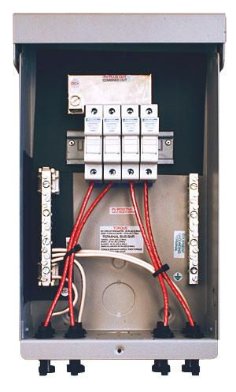
Model | Price | Size | Shipping | Weight
MNPV4-MC4 | $396.00 | 13.5"L X 8"W X 3.5"D | 11"L X 5"W X 4"D | 5 Lbs
DOCUMENTS
WEBINAR/VIDEOS
PHOTO DOWNLOAD
DESCRIPTION:
This 3R Pre-Wired MNPV4 Combiner Is Rated For Outdoor Use. Designed For Combining High Voltage Strings Using Standard 10mm X 38mm Fuses Up To 80 Amps Total.
The Pre-Wired MNPV4 Combiner Is Rated For Outdoor Use. Designed For Combining High Voltage Strings Using 10mm X 38mm Fuses Up To 80 Amps Total. The Use Of Touch Safe Din Rail Mount Fuse Holders ( MNTS) And Fuses Allow Operation Up To 600 Volts. The MNPV4 Is Rated For Up To 80 Amps.

INCLUDED FEATURES
- Type 1 Environmental Rating
- Fast, Convenient Hook Up With Industry Standard Connectors
- All Aluminum Powder Coated Housing That Won't Rust
- Flip Up Cover That Can Stay In The Open Position During Installation
- PV Negative Bus Bar With #6 And 1/0 Connections
- Chassis Ground Bus Bar With #6 And 1/0 Connections
- Standard DIN Rail With (X) 30 Amp Touch Safe Fuse Holders. 15 Amp Fuses Included
- Tin Plated Copper Bus Bar That Connect PV Plus Outputs
- Dead Front Cover (MNPV6DF) Snaps Into Place After Wiring Is Complete For Safety
- Connectors For PV In And PV Out On Bottom, Additional Knockouts On Bottom And Sides
- Top Surface Is Available To Bring Conduit In From Directly Above The Enclosure
Pre-Wired Ad
- Warranty - 5 Yrs.
- Listed By ETL For US & Canada
- Made In The USA
California Residents: Warning
ACCESSORIES
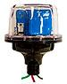
MNSPD-600 - $135.00
The MidNite Solar 600V Surge Protector Device (MNSPD) Is A Type 1 Device Per UL1449 Rev3 And Has An Outdoor Rating Of 4X For Outdoor Use. Protection For Grid-Tie PV Combiners And Inverter Input Circuits.

