MNPV6-250 DISCO
(Previous Model Num: MNPV6-250-DISCO)
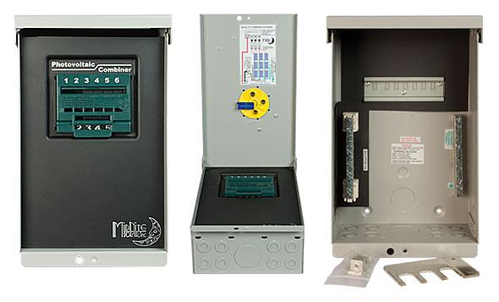
Model | Price | Size | Shipping | Weight
MNPV6-250 DISCO | $346.00 | 13.2"L X 8"W X 6.2"D | 15"L X 9"W X 7.25"D | 6 Lbs
DOCUMENTS
WEBINAR/VIDEOS
PHOTO DOWNLOAD
DESCRIPTION:
Enclosure Only - NOT COMPATIBLE WITH THE BIRDHOUSE.
This 3R MNPV6-250 DISCO Combiner Is One In A Series Of Disconnecting PV Combiners From MidNite Solar. This Model Includes The Buss-Bar To Use Up To 3 Of Our 300 Volt DC Breakers As A 3 String DC Combiner.
The MNPV6-250 DISCO's Red Handled Is LOCKABLE IN THE OFF POSITION!

Off-Grid PV Combiner For Use With Up To 3 300VDC Breakers With The Included Buss-Bar. Also Included Is The Deadfront (MNPV6DF) And The MNPV6-DISCO-SLIDER. Load Break Rated.

Depending Upon The Model Number, You Can Use:
- Type 3R Environmental Rating
- DC 600V (1 Circuit Pos Or Pos And Neg Switched) Part No. MNPV6
- DC 300V (3 Circuits) Part #MNPV6-250
- DC 150V (6 Circuits) Part #MNPV6
- AC 120v 20 Amps (6 Circuits) Part #MNPV6
- AC 240v 40 Amps (3 Circuits) Part #MNPV6-AC Micro
- AC And DC Can Be Installed In The Same Box!
Example:
600Vdc 20 Amp PV In And 40 Amp 240Vac Inverter Output
Enclosure Only With The Busbar Shown.

MNPV6 3R Disco Assy Instructions
- Warranty - 5 Yrs.
- Listed By ETL For US & Canada
- Made In The USA
California Residents: Warning

