MNPV6-250
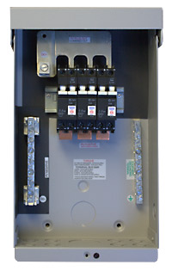
Model | Price | Size | Shipping | Weight
MNPV6-250 | $205.00 | 13.5"L X 8"W X 3.5"D | 14"L X 9"W X 4"D | 5 Lbs
DOCUMENTS
WEBINAR/VIDEOS
PHOTO DOWNLOAD
DESCRIPTION:
Enclosure Only
(For 200 And 250 VDC Charge Controllers) Gray Aluminum Type 3R Rainproof Enclosure With Insulating Dead Front, Will Accept Three 300 VDC MidNite Solar Breakers.
Breakers Sold Separately.
Photo Shows MNPV6-250 With 3 Of The MNEPV 300 Volt Breakers.
Includes 15 Position PV Negative Bus Bar, 14 Position Ground Bus Bar, 168 Amp Plus Bus Bar For 300 Volt Breakers.
- Type 3R Environmental Rating
- Warranty - 5 Yrs.
- Listed By ETL For US & Canada
- Made In The USA
California Residents: Warning

