MNPV6-DISCO AC MICRO
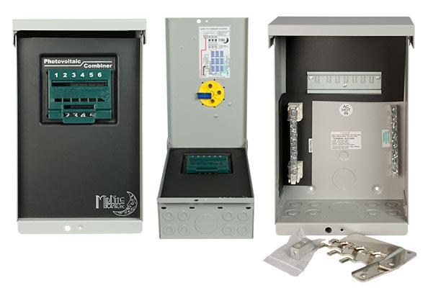
Model | Price | Size | Shipping | Weight
MNPV6-DISCO AC MICRO | $375.00 | 13.2"L X 8"W X 6.2"D | 15"L X 9"W X 7.25"D | 7 Lbs
DOCUMENTS
WEBINAR/VIDEOS
PHOTO DOWNLOAD
DESCRIPTION:
Enclosure Only - NOT COMPATIBLE WITH THE BIRDHOUSE.
This 3R Enclosure Includes 2 Busbars. Can Use Up To 3 Of Our 240 VAC Breakers To Combine Up To 3 Strings Of 240 Volt Micro Inverters.
The MNPV6-DISCO AC MICRO's Red Handled Is LOCKABLE IN THE OFF POSITION!

This 3R Enclosure Includes 2 Busbars. Can Use Up To 3 Of Our 240 VAC Breakers To Combine Up To 3 Strings Of 240 Volt Micro Inverters. Can Be Used Up To 150 Amps And 1/0 Wire. Load Break Rated. Lockable In The Off Position. Included Is The Deadfront (MNPV6DF) And The MNPV6-DISCO-SLIDER

Depending Upon The Model Number, You Can Use:
- Type 3R Environmental Rating
- DC 600V (1 Circuit Pos Or Pos And Neg Switched) Part No. MNPV6
- DC 300V (3 Circuits) Part #MNPV6-250
- DC 150V (6 Circuits) Part #MNPV6
- AC 120v 20 Amps (6 Circuits) Part #MNPV6
- AC 240v 40 Amps (3 Circuits) Part #MNPV6-AC Micro
- AC And DC Can Be Installed In The Same Box!
Example:
600Vdc 20 Amp PV In And 40 Amp 240Vac Inverter Output
- Lockable Disconnect
- Warranty - 5 Yrs.
- Listed By ETL For US & Canada
- Made In The USA
This Photo Demonstrates Proper Wiring For The MNPV6-DISCO AC MICRO. (Wires Are Not Provided And Breakers Are Sold Separately.)
