MNPV6-GFP15-35DC
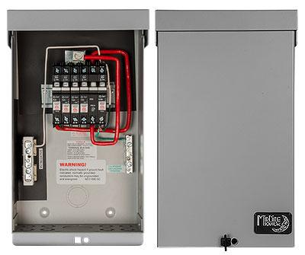
Model | Price | Size | Shipping | Weight
MNPV6-GFP15-35DC | $495.00 | 13.5"L X 8"W X 3.5"D | 14"L X 9"W X 4"D | 5 Lbs
Model Options
Model | Price | Description
MNPV6-GFP15-DC | $475.00 | Same As The MNPV6-GFP15-35DC Except Without The 35 Amp Breaker
DOCUMENTS
WEBINAR/VIDEOS
PHOTO DOWNLOAD
DESCRIPTION:
Gray Aluminum Type 3R Rainproof Enclosure With Insulating Dead Front
Photo Shows MNPV6 Chassis With 3 15amp 150volt Input Breakers, A Single 35 Amp Pv Disconnect Breaker And A 63amp Ground Fault Breaker. This Box Is Designed To Combine 3 Strings Of PV And Feed Them To A DC Load That Is Designed To Be Directly Driven From A PV Array. Something Like Water Pumping, DC Pool Pums Or Air Conditioning For Example (WARNING Not An Alternating Current AC Load)

- Type 3R Environmental Rating
- Warranty - 5 Yrs.
- Listed By ETL For US & Canada
- Made In The USA
California Residents: Warning

